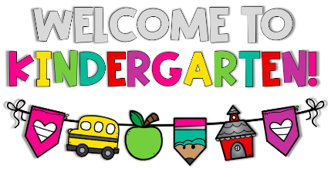
2024 - 2025
All students will need:
- One backpack (No wheels, please)
- One lunch box for snacks, snacks should be sent in daily with your child.
- One refillable water bottle (No Stanley water bottles because they spill easily)
- 1 large heavy duty pencil pouch with zipper pockets
- 1 pkg. of large pink erasers
- 2 dozen #2 pencils
- 1 box of 8 Crayola washable markers (Thick)
- 1 box of Crayola color pencils
- 4 boxes of Crayola crayons (24 count)
- 1 pack of Jumbo Elmer’s glue sticks
- 1 pack of Small Elmer’s glue sticks
- 1 plastic folder with PRONGS and pockets: red
- 1 wide ruled Primary composition book (with space to draw a picture)
- Disinfectant wipes
- Baby Wipes
- Box of Tissues
- Paper towels
- 1 pack of magic erasers (Mr. Clean)
- bottle of hand sanitizer
TEACHER WISH LIST
* Individually wrapped candy or treats
* small treasure box toys
*Snacks (Cheez-its, animal crackers, fruit snacks, Goldfish, or assorted chips)

