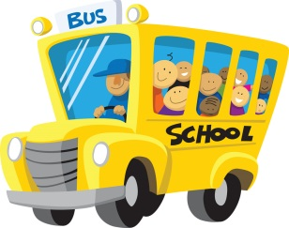Impact Christian Academy First Grade Supply List

2024 - 2025

All students will need:

* One backpack (No wheels, please.)
* One refillable water bottle (Please, no Stanley water bottles because they spill easily.)
* 1 1” binder
* 1 pair of scissors
* 1 large heavy-duty pencil pouch with zipper pockets
* Disinfectant wipes
* Baby Wipes
* Box of Tissues
* 1 pkg. of large pink erasers
* 2 dozen Ticonderoga #2 pencils
* 1 pkg. of .09 BIC mechanical pencils
* 1 pack of Expo markers
* 1 whiteboard eraser
* 1 box of 8 Crayola washable markers
* 1 box of Crayola color pencils
* 4 boxes of Crayola crayons (24 count)
* 1 pack of **Jumbo** **Elmer’s** glue sticks
* 1 pack of **Small Elmer’s** glue sticks
* 2 **plastic** folders with PRONGS and pockets: yellow and blue
* 1 wide ruled **Primary** composition book (with space to draw a picture)
* 1 wide-ruled composition book
* Paper towels
* 1 pack of magic erasers (Mr. Clean)
* 1 bottle of hand sanitizer

TEACHER WISH LIST

* white cardstock paper (110 lb.) * Scotch tape

* individually wrapped candy or treats * small treasure box toys

* snacks (Cheez-its, animal crackers, fruit snacks, Goldfish, or assorted chips)