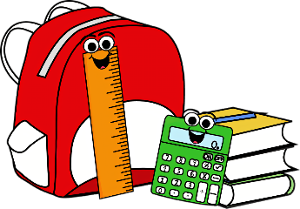
Impact Christian Academy
Third Grade Supply List

- 2 packages of 100 sheet wide-ruled loose leaf paper
- 3 dozen sharpened No. 2 pencils
- 2 large pink erasers
- 1 box of Crayola crayons or markers
- 1 pack of colored pencils
- 4 glue sticks
- Scissors
- 1 container of disinfectant wipes
- 2 boxes of Kleenex
- 1 bottle of hand sanitizer
- 1 package of construction paper (assorted colors)
- 3 plastic three prong pocket folders (blue, purple, green)
- 1 box of Zip Lock Bags - sandwich or gallon size
- 1 large heavy duty pencil pouch
- 1 pack of skinny dry erase markers
- 1 bookbag without wheels
- 1” binder
- 4 composition notebooks (wide ruled)

Wish List:
- Any color Cardstock Paper
- Colored Copy Paper
- Wrapped Candy
- Indoor Recess Games
- Small Toys for Treasure Box
- Scotch Laminating Paper

Thank you!

