Kindergarten School Supply List
2023-2024
All students will need:
- 1 backpack (no wheels please)
- Scissors blunt tip
- 5 pack of purple glue sticks
- 1 large container of Clorox wipes
- 1 package of baby wipes
- 1 can of Lysol Disinfectant Spray
- 1 3ct. box of facial tissue
- 1 pack of gallon sized Ziploc bags
- 1 pack of quartz sized Ziploc bags
- 1 pack of large pink erasers
- 1 4ct. of jumbo pencils
- 1 crayon box
- 1 pack of regular pencils
- 1 16ct. box of crayons
- 4 24ct box of crayons
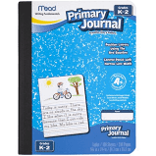
- 1 wide ruled composition books (yellow)
- 2 Primary journals
- 2 pocket folders (green, blue)
- 2 rolls of paper towels
- 1 pack of collated construction paper

