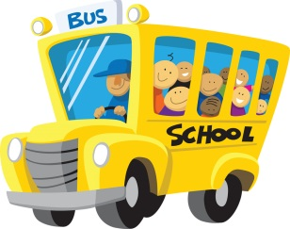
First Grade Supply List
2023-2024
All students will need:
- One backpack (No wheels, please.)
- 1 large heavy duty pencil pouch with zipper pockets
- Clorox/Lysol wipes
- 1 package of Baby Wipes
- Tissues
- 1 pkg. of large pink erasers
- 1 pkg. of cap erasers
- 2 dozen Ticonderoga #2 Pencils
- 1 pack of Expo markers
- 1 white board eraser
- 1 box of 8 Crayola washable markers
- 1 box of Crayola color pencils
- 3 boxes of Crayola crayons (24 count)
- 1 pack of Jumbo Elmer’s glue sticks (large)
- 2 plastic folders with PRONGS and pockets: yellow and blue
- 1 wide ruled Primary composition book (with space to draw a picture)
- 2 wide ruled composition books
- 1 pkg. of 100 sheet wide-ruled loose leaf paper
- Paper towels
- 1 pack of magic erasers (Mr. Clean)
- 1 bottle of hand sanitizer
TEACHER WISH LIST
* individually wrapped candy or treats * small treasure box toys
* pastel multipurpose printer paper * individually wrapped Goldfish and Gummies
THANK YOU

